Audit Service & Certification aware of the importance of impartiality in independent third party certification activities makes this statement known to all interested parties.
Audit Service & Certification has carried out an analysis of the threats to its impartiality and will constantly monitor any significant changes over time.
Threats can be defined as follows:
- Self-interest threats: threats that arise from a person or organisation acting for its own interests.
- Self-review (undue advice): a threat arising from a person or organisation during the certification review of the advice it has previously provided.
- Familiarity threat (trust): threat arising from a person or organisation being overly familiar with or trusting another person instead of detecting audit evidence. Such familiarity is a threat to impartiality.
- Intimidation threat: threats arising from a person or entity perceived to be in a state of coercion, whether overt or not, such as a threat of recusal or reporting to a superior.
The following methods have been implemented for the purposes of containing threats and related factors.
The following modalities have been implemented for the purposes of threat containment and related factors:
- signing of confidentiality and absence of conflict of interest commitments by all the above-mentioned persons;
- annual meetings of the Committee for Safeguarding Impartiality made up of the parties involved in certification;
- training of all personnel not to discriminate against applicants for certification;
- use of auditors competent for certification activities and trained according to AS&C procedures;
publication of the Certification Rules
- analysis of complaints and appeals as per AS&C General Rules
- respect for the principle of confidentiality
- respect of the principle of security and privacy.
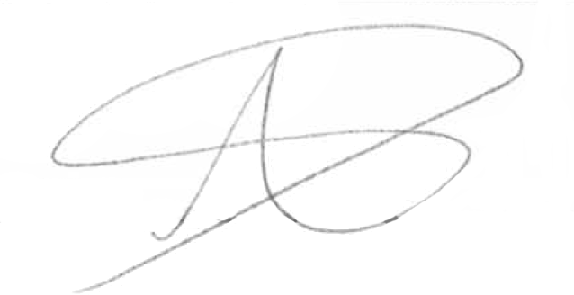
Signature

